Another Chinese Occupation Dream
April 12th, 2021

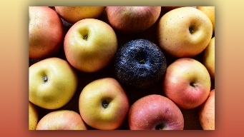
Lord May the Lord bless you and give you His peace dear Heartdwellers. This is Mother Elisabeth and one morning I was holding an apple in my hand getting ready to eat it. The apple was beautiful, red and delicious looking, I couldn’t wait to sink my teeth into the apple, so my prayer of thanksgiving for the Lord’s provision was a bit rushed. I bit into the lovely apple and the inside was brown, squishy and rotten. I thought ‘ughh!’ and promptly spit it out. It boggles the mind, that what is so appealing on the outside was rotten and inedible on the inside.

The apple reminded me of a dream I recently had. I was walking in town and was extremely hungry, a woman came up to me with a whole pan full of yummy looking, golden colored cornbread. Now, I love cornbread, it’s one of my favorite sides with any meal, but Holy Spirit prompted me that she was a witch and this was a trap, because the cornbread was laced with poison in the form of curses and strongholds which she wanted me to consume. When I refused to eat the cornbread, she proceeded to tell me that my brother, David had eaten the cornbread and the poison was much stronger in his portion. The witch went on to explain that due to others praying for me and saying the binding prayer daily, this provided a hedge of protection around me that was difficult

